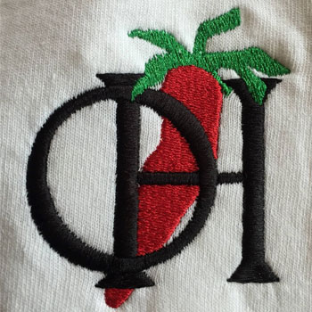 CHILI APPRECIATION

SOCIETY INTERNATIONAL

**18351 Corkys Ln, Culpeper** VA

**2024 VIRGINIA STATE CHILI CHAMPIONSHIPS & FUNDRAISER FOR THE FISHER HOUSE FOUNDATION AND PANCREATIC CANCER**

**OLD HOUSE WINERY / DISTILLERY / BREWERY AND THE CHILI APPRECIATION SOCIETY ARE AGAIN JOINING CRUISIN FOR HEROES FOR A *DUAL CHARITY FUNDRAISER***

**SATURDAY, JUNE 15TH 12 – 6PM & LIVE MUSIC 1-4PM**

**VISITORS WILL BE ABLE TO SAMPLE SOME OF THE BEST VIRGINIA CHILIS THROUGHOUT THE EARLY AFTERNOON. THIS FUNDRAISING EVENT IS IN SUPPORT OF PANCREATIC CANCER AND THE FISHER HOUSE FOUNDATION WITH SAMPLE DONATIONS BASED AND 100% OF THE EVENT PROCEEDS GOING TO THESE CAUSES.**

**A CRUISIN FOR HEROES / FISHER HOUSE BOOTH WILL ALSO BE SET UP**

**FOR INFORMATION AND ADDITIONAL DONATIONS**

 **A FAMILY FRIENDLY EVENT SUPPORTING OUR MILITARY & COMMUNITY**